7/15/2016

Avijeet Mishra

University at Buffalo

50169242

AVIJEETM@BUFFALO.EDU

PROJECT REPORT

PROJECT 2

**Q1:**

9x9 Disparity Left

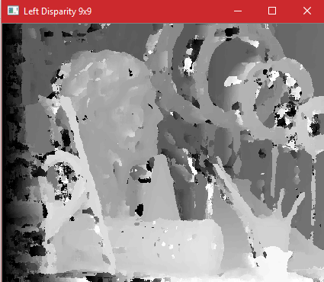

9x9 Disparity Right

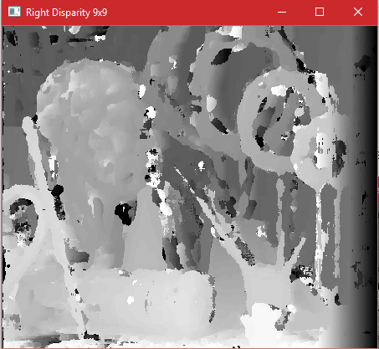

9x9 Back Projection Left

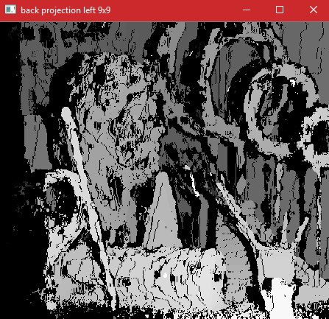

9x9 Back Projection Right

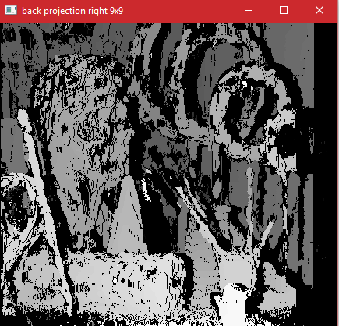

3x3 Disparity Left

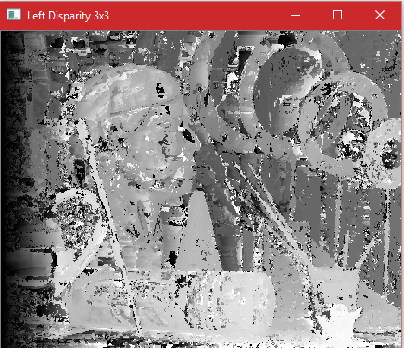

3x3 Disparity Right

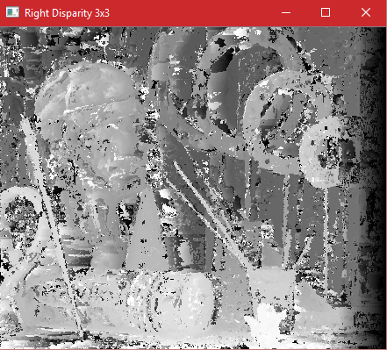

3x3 Back Projection Left

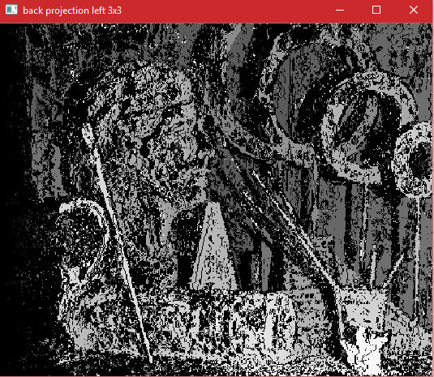

3x3 Back Projection Right

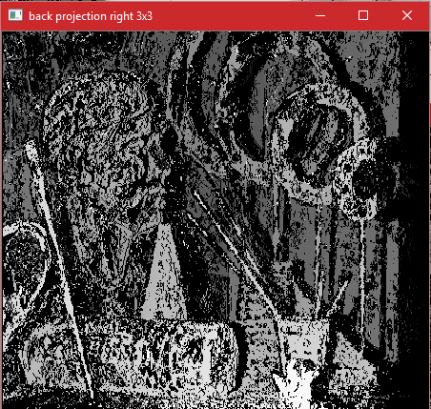

Mean Square Error using Disparity Map

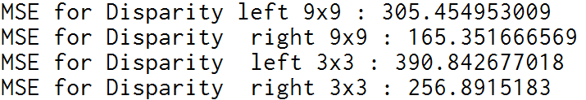

Mean Square Error using Back Projection

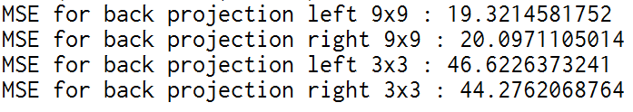

**Q2:** Dynamic Programming

Disparity Left:

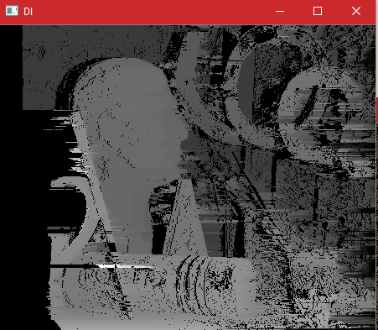

Disparity Right:

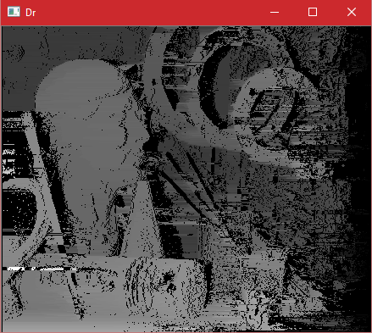

**Q3:**

Final Output

